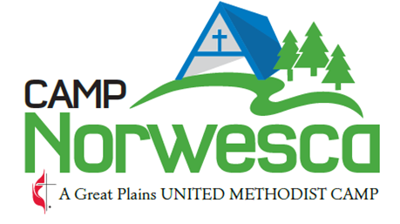

TITLE: Kitchen Assistant

Direct Supervisors: Head Cook

Mission Statement:

Camp Norwesca is a United Methodist Camp whose mission is to create Disciples of Christ by providing a safe and fun environment, where campers and retreat groups can grow in their faith, renew, unplug, and develop life skills through intentional programming and spiritual enrichment.

GENERAL STATEMENT

The camping program of Camp Norwesca is an outreach of the Great Plains Conference of the United Methodist Church for the purpose of providing experiences through which all persons (without regard to religious affiliation, sex, age, social status, etc.) can grow in the Christian faith, discover the power of Christian community, and experience the world in which God has placed us all. While membership in the United Methodist Church is not a requirement of employment, active participation in a Christian church is expected. In addition, a general requirement for employment is that staff must feel comfortable in this setting and be able to be supportive of this ministry. Being of service to people and extending the greatest degree of courtesy to people is a very real and important requirement of all staff.

Minimum Qualifications:

* At least 16 years of age
* A desire to work in a camp kitchen.
* Ability to learn to do task assigned
* Ability to work well with others.
* Ability to accept supervision.

Training Required:

- First Aid and CPR certifications (If hired this will be provided by Camp Norwesca during staff training)
- “Safe Gatherings” Certification

Kitchen Responsibilities:
- Ensure all food prep, storage, dishwashing and personal hygiene requirements of the Nebraska Department of Health and Human Services are met.
- Wash dishes, glasses, wash pots and pans, silverware, and all utensils for all meals served.
- Sweep and mop Kitchen daily, as needed.
- Remove trash from kitchen and dining room area to the dumpster.
- Assist Cooks in food prep and serving
- Responsible for all setup and cleanup of Salad Bar, drink station, and toaster area.
- Ensure all areas are well supplied and cared for according to the Nebraska Department of Health and Human Services guidelines.
- Clean dishwasher at the end of each meal cleanup.
- Straighten counter tops and clean off after each meal.
- Clean and disinfect sinks, stovetops, counter tops daily.
- Clean and scrub trashcans in the kitchen and dining room routinely.
- Clean and disinfect refrigerators, walk in, and microwaves on the inside and out.
- Assist in unloading supply trucks, following food rotation routines to keep all supplies fresh and in date.
- Help open and prepare the kitchen for summer use and end of summer cleanup, storing items not used on a regular base once summer is over.
- Report any equipment or supplies needed to the Head/Camp Cook.
- Complete all evaluation reports, incident accident reports and follow all policies and guidelines of the facility.
- Attend staff meetings and trainings as scheduled.
- Clean the Kitchen and Main Dining Area thoroughly at the end of the week to prepare for the next week.
- Clean and stock Lodge restrooms daily.
- Other duties as assigned.]

Benefits:

Pay: Currently this is an hourly position with a rate for pay of $12/hr. – checks or direct deposit arriving by the 15th and the 30th. Pay rate to be recommended and set annually by Camp Director in consultation with Camp Norwesca Site Council.
Hours: approximately 20-25 hours per week in the summer and not to exceed 50 hrs. in a two- week period during the summer schedule, which may include Saturday or Sunday. Meals will be provided when being cooked in the Dining Hall. You will not be paid for personal time away or for meals off camp.

Please complete the following statement and sign:

I, ___________________________________________ have read the job description, understand, and will do my very best to fulfill the above responsibilities of a kitchen assistant for Camp Norwesca’s Ministry Programs. I do give ______/ I do not give______ my permission to use photos of myself in promotional materials for Camp Norwesca.

___________________________________________________________________ Date _________________________
Signature

