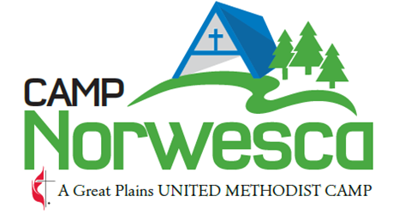

Title: Maintenance Staff
Direct Supervisor: Camp Director
MISSION STATEMENT
Camp Norwesca is a United Methodist Camp whose mission is to create Disciples of Christ by providing a safe and fun environment, where campers and retreat groups can grow in their faith, renew, unplug, and develop life skills through intentional programming and spiritual enrichment.
GENERAL STATEMENT
The camping program of Camp Norwesca is an outreach of the Great Plains Conference of the United Methodist Church for the purpose of providing experiences through which all persons (without regard to religious affiliation, sex, age, social status, etc.) can grow in the Christian faith, discover the power of Christian community, and experience the world in which God has placed us all. While membership in the United Methodist Church is not a requirement of employment, active participation in a Christian church is expected. In addition, a general requirement for employment is that staff must feel comfortable in this setting and be able to be supportive of this ministry. Being of service to people and extending the greatest degree of courtesy to people is a very real and important requirement of all staff.

Minimum Qualifications:
- Experience driving a zero-turn lawn mower
- Experience running small engine equipment (chainsaws, weed eater, etc.)
- Experience driving tractors
- Training/experience mixing fuel for small engines
- Training/experience in the use of safety equipment (gloves, eye protection, etc.)
- At least 18 years of age
Training Required:
- First Aid and CPR Certification (if hired this will be provided by Camp Norwesca at staff training_
- Safe Gatherings Certification

General Responsibilities:
- Check all maintenance equipment prior to use. This to include all tractors, mowers, weed eaters and other grounds equipment.
- Responsible for the daily care, maintenance, and improvement of Camp Norwesca’s grounds.
- Keep the grounds clear of tree limbs and debris while mowing and trimming. (Walk each area before you mow)
- Responsible for garden care (weeding, watering, etc.)
- Responsible for watering grass and trees via sprinklers.
- Clean, service and maintain all camp lawn care equipment.
- Clean out the lawn mower decks after each use.
- Clean and organize the shop.
- All hazardous materials such as gasoline, weed killer, and oil is kept in its appropriate place
- Maintain all of camps hiking trails
- Spray sidewalks, paths, archery range, and firepit areas for weeds
- Maintain all camp fences
- Report any malfunctioning equipment to the Camp Director
- Report any supplies needed
- Stock firewood as needed
- Trim trees in mowed areas and along the driveway as needed.
- Evaluate current season and make recommendations for the next season.
- To attend staff meetings as scheduled.
- Other duties as assigned, which may include cleaning, painting, and small repairs.

Benefits:
Hours for this position is to be determined annually by the Director of Camp Norwesca. Hours: vary according to the seasonal schedule and not to exceed 80 hrs. in a two- week period.

Please complete the following statement and sign:
I, ___________________________________________ have read the job description, understand, and will do my very best to fulfill the above responsibilities of Grounds Keeper for Camp Norwesca’s Ministry Programs. I do give ______/ I do not give______ my permission for the Camp to use photos of myself in promotional materials for Camp Norwesca.

___________________________________________________________________ Date _________________________
my signature

3/2023
Staff Job Positions\Maintenance Staff.doc

